Systems Requirements Specification Document

Team 7C

# Authors

|  |  |  |
| --- | --- | --- |
| Name | Main Section | Signature |
| Thomas Chate | Introduction and Glossary |  |
| Lillie Hogg | Functional Requirements |  |
| Luke Jackson | User Requirements |  |
| Greg Lindert | User Requirements |  |
| Tomasz Szelachowski | Non-Functional Requirements |  |
| Pawel Szymczyk | User Requirements Method |  |

# Revision History

|  |  |  |  |
| --- | --- | --- | --- |
| Version | Authors/Editors | Date | Description |
| 1.0 | Thomas Chate | 05-11-16 | Document Created |
| 2.0 | All | 09-11-16 | Initial Draft |
| 3.0 | Pawel Szymczyk | 12-11-16 | Added user requirement method |
| 4.0 | Greg Lindert | 14-11-16 | Added more of user requirements |
| 5.0 | Lillie Hogg | 14-11-16 | Functional and Nonfunctional system requirements added. |
| 6.0 | All | 16-11-16 | Feedback received from Claudia.  Edits made. |
| 7.0 | Lillie Hogg | 17-11-16 | Functional Requirements draft 2 |
| 8.0 | Thomas Chate | 18-11-16 | Spelling and Grammar Check and Format improvement (Whole Document) |
| 9.0 | Thomas Chate | 19-11-16 | Added Glossary and signature declaration. |
| 10.0 | Luke Jackson | 20-11-16 | Edited Requirements Elicitation document and Software Model document for future reference and made small wording/grammar changes while proof-reading final document. |
| 11.0 | Thomas Chate | 20-11-16 | Final Document Check |

# 

# 

# 

# 

# 

# 

# 

# 

# 

# 

# 

# 

# 

# 

# 

# 

# 

# Introduction

This is the Systems Requirements Specification document (SRS). The purpose of this document is to ensure that the developed software meets all of the defined requirements.

This document refers to the development of ComPChecker (Computer Part Checker), this name is only an internal developmental project name and may change on release of the software.

Below are the functions of ComPChecker:

* Users can create an account.
* Users can create many builds.
* Ensure compatibility between parts selected by the users.
* Provide the user with most compatible component.
* Access the part database on the server.

ComPChecker will be an application, downloaded by the user from a website. ComPChecker will work on Windows 8 onwards OSs. Once installed, users will be able to run the program and create an account. From here they can create builds using the parts in the server’s database.

There is a popular similar web-based system to ComPChecker (<https://uk.pcpartpicker.com/>). This system allows users to select components and will only display other components which are compatible this function will be used in ComPChecker. However, ComPChecker will inform the user of the best choice (as some components are more compatible than others).

# Glossary

**PC:** Personal Computer, the actual machine/hardware itself.

**Builds:** A set of components which form a fully working PC.

**Compatible/Compatibility:** When components can occur in a build without problems or conflict.

**Component:** A piece of hardware inside a PC, for example, CPU.

**ComPChecker:** The name of the system.

# Elicitation Method for User Requirements

The project is a medium-risk, long-term task. We had many questions about requirements, because complex and significant changes are frequently expected throughout the course of the project. We want to ensure that the system meets the user requirements; therefore we questioned and interviewed users at an early stage.

We are using three different methods for eliciting user requirements:

* Interview
* Questionnaire
* Prototyping (future)

The combination of these methods will allow us to have a full understanding of the users wants and needs. We will implement this using the spiral model; going back to our initial users throughout development to see if their needs have been met and if anything requires changing or improvements.

Using an online questionnaire we were able to obtain requirements from a large volume of users. We combined this method by interviewing some users to get more detailed requirements, these were entered into the questionnaire results table. The main aims of these requirement elicitation methods were to obtain functionality and accessibility requirements. The questionnaire is located at **appendix 1** with the results at **appendix 2**.

The questionnaire was discussed by the team and created in a Google Form, then it was sent on social media (Facebook) asking them to complete. Also we targeted friends and family who (or are interested) had built a PC.

On the questionnaire we got fifteen responses, approximately the age of responders was twenty. There was fourteen questions divided into three sections: demographics, IT Use, Functionality and Use.

We interviewed 3 users (two general and one admin) we used the questionnaire as a template filling out their responses and asking more detailed questions where needed. The interview was conducted with three people between 18 and 25 year olds. Each interview took ~15 minutes.

Before each completed prototype; questionnaires, user and system requirements are checked by interviewing users. From the feedback requirements may be updated with agreement from both users and team.

# User Requirements

|  |  |  |  |
| --- | --- | --- | --- |
| **No.** | **Ranking** | **Requirement** | **Rationale** |
| 1 | M | The user will be able to create an account from which they can manage their builds. | This is the core functionality of the system. |
| 2 | M | The user will be able to create many builds of compatible parts. |
| 3 | M | The system will reject components that are not compatible with the system. |
| 4 | M | User interface will be menu driven, it will contain radio buttons, help screens, input boxes , dialog boxes and drop down list boxes. | These features make the system easier to use and provide a cleaner end-user experience. |
| 5 | M | The finished build will be displayed with all parts used. | **Based on feedback**, it was important to users to be able to view prices of parts and their build. |
| 6 | M | The prices for each part will be displayed. |
| 7 | M | The overall price of the build will be displayed |
| 8 | M | Prices will be displayed in £ |
| 9 | M | The user should be able to create a fully functional build with no compatibility issues. | This is a basic requirement expected from the user. |
| 10 | D | The system will provide many alternative options for the most up to date, compatible components. | Some users will prefer specific brands or simply wont like an option presented, so other options need to be available. |
| 11 | D | The user can compare their build to any build on the database. | Some users have expressed being able to compare builds with each other out of curiosity, or to seek guidance/advice on better builds. |
| 12 | D | Users can see other users builds. |
| 13 | O | The user should be able to share their builds with other users. |
| 14 | O | The user can compare two (or more) of their own builds. | This feature adds a useful feature for the user which adds depth to the system. |
| 15 | O | The user should be able to print off a checklist (shopping list) | This is a quality of life feature that would provide a more useful user experience. |
| 16 | O | Users can view pictures of components. | This is an aesthetic feature and educates the users of the components. |
| 17 | E | Each build receives a performance ranking. | This small feature would allow users to compare builds at a glance. |
| 18 | E | Users can comment or upvote each other's builds. | Increases the social factor of the system. |
| 19 | E | The system will automatically update with new prices. | Ensures our users always get the right prices. |
| 20 | E | The system will have a filter built in which allows users to set limits for particular constraints e.g. price, supplier. | This would allow the user to more directly tailor their build to their budget or preferences. |

## Key:

* M - Mandatory requirement. This feature **must** be built into the final system. It is core functionality.
* D - Desirable requirement. This feature **should** be built into the final system unless the resource/time cost is too high.
* O - Optional requirement. This feature **could** be built into the system if we see fit to implement it.
* E - Possible future enhancement. This feature **may** be used in the final system, however it may not to limit scope.

# Functional Requirements

This is the behaviour of the system, and what the user will be able to expect from the software, the services the system should provide, how the system will react to its inputs, and what the system should not do.

|  |  |
| --- | --- |
| **No.** | **Requirement** |
| **1** | The system will include a search feature, enabling users to search for a specific component type from a given component list. |
| **2** | The system will generate a list of PC components which the user can select from. |
| **3** | The system will enable a user to select an Intel component from a given component list, component list will be in the form of a drop down menu. |
| **4** | The system will check a components compatibility with another component using the components specification for supported speed, power, size and sockets. |
| **5** | The system shall be able to produce ‘help’ information for each individual component, specifying what the component is and what it is used for. If help is required from the user. |
| **6** | System permits authorization of a user through unique username and a set password, to enable the user to start creating a PC build. |
| **7** | The system shall be able to save PC builds through user accounts, and can identify each user from their set username and password. |
| **8** | The system should output the specification of a component when it is selected by the user, the name, detailed description, image, size, power, compatibility. |
| **9** | The system shall generate a retail price for each of the selected components. |
| **10** | The system should output the specification of a component when it is selected by the user, the name, detailed description, image, size, power, compatibility. |
| **11** | The system shall output the contents of the build once the user has completed their PC and has confirmed they have finished their build. |
| **12** | System should not require a powerful machine to run, a standard low end machine should be able to run the program |
| **13** | System must be compatible with windows 8, 8.1, and 10. |
| **14** | System permits authorization of a admin through unique username and a set password, to enable the admin to maintain the application system. |
| **15** | System must allow Admin to add components to the application |
| **16** | System must allow Admin to remove components from the application |
| **17** | Admin must be allowed to update component content in the application system |
| **18** | Admin will maintain the database server which produces compatibility of selected products |
| **19** | System shall allow admin to produce backup data for the application. |
| **20** | Admin shall be able to see closed and deleted users in the application. |
| **21** | System shall allow an admin to maintain user accounts for any errors. |
| **22** | System shall allow an admin to disable a user account when needed. |
| **23** | System shall allow admin to maintain application security and notify with any errors |
| **24** | System shall allow an admin to modify items on the application |

# Non-Functional Requirements

|  |  |  |
| --- | --- | --- |
| **No.** | **Requirement** | **Testing/Validation Method** |
| **Speed** | | |
| **1** | The system will work on any basic computer system and will be able to have 1000 users at any one point without affecting the run speed of the software. | We will test the amount of users by stress testing the system and then Load testing which will record response times. |
| **Size** | | |
| **2** | The program will be small enough for it to be put onto a portable drive and will be 50 MB. | This will be tested by using file properties and ensuring it is under the said amount. |
| **Ease of Use** | | |
| **3** | The system should be easy to use by any user no matter their IT skill or knowledge and should be organized in such a way that user errors are are very rare. | This will be tested by running a trial with a user with high and low skills. |
| **4** | The system shall be accessible to all. | This will be validated by giving it to a wide variety of users and seeing if the core functionality can be completed without support. |
| **Reliability** | | |
| **5** | The system will be reliable as it will be impossible to choose non-compatible parts.The Mean Time Between Failures (MTBF) of the system will be 100 hours. | The system will be tested by checking the MTBF. |
| **Robustness** | | |
| **6** | When creating an account, all fields will be checked to ensure the right information has been provided. | This will be tested during the stress test to make sure the system doesn’t fail. |
| **7** | All text fields will be spellchecked to ensure the lack of errors | This will be tested by going through all the text fields. |
| **Portability** | | |
| **8** | The software will be portable and all it will take to move from one platform to another is a portable drive, or access to the internet. | The program will be downloaded and installed to test if it works, and will then be moved from one device to another via a usb stick. |
| **Update** | | |
| **9** | Users will update the program using the “Update Centre” to update the software, at any one point 200 users can use the update centre at the same time. | This will be tested when load testing the system. |
| **Security** | | |
| **10** | Only the user who created a specific system can access that system unless they share it with another user, admins will be able to see them however will not have the permissions to edit them. | This will be tested when security testing the system, and by having users create builds and share them with each other. |
| **Accuracy and Precision** | | |
| **11** | The system information will be accurate to 90%, updated when new information is released. | The accuracy of the system will be tested by comparing the numbers to those which are officially showed by manufacturers. |
| **Features** | | |
| **12** | The search feature will have an autofill part coded in to ease finding components. | The features will be tested by doing a trial run of the software. |
| **13** | Each drop down menu and fillable text box will be validated making sure the correct information is typed in. |

# 

# Appendix 1: Questionnaire

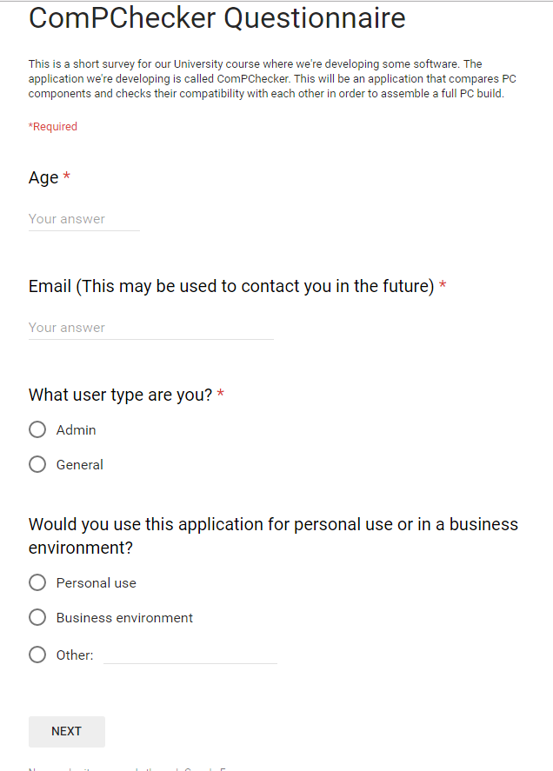

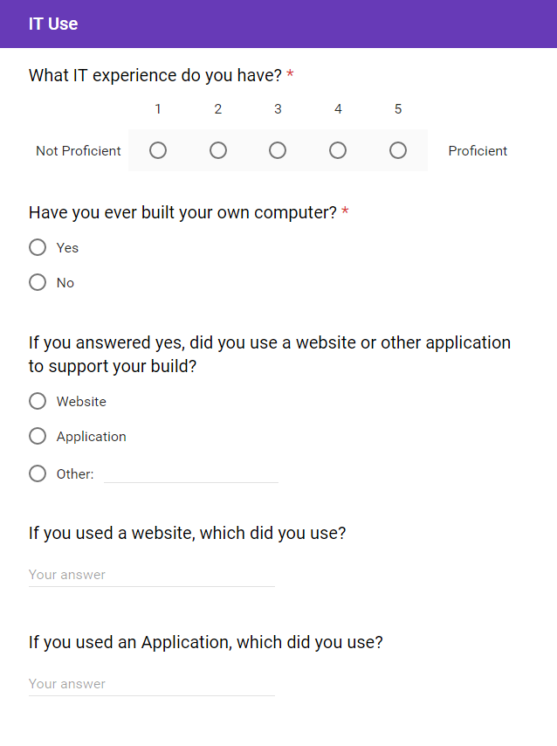

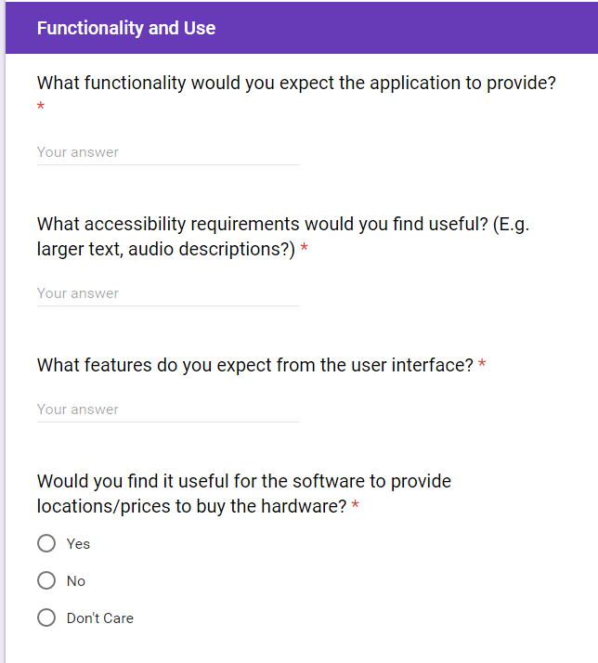

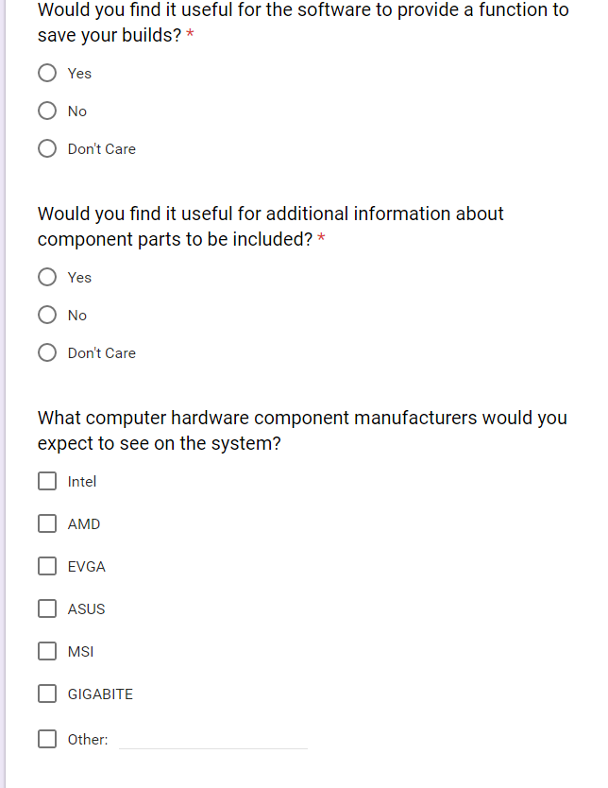

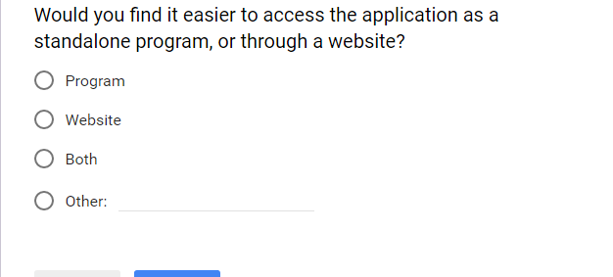

# **Appendix 2** Questionnaire results

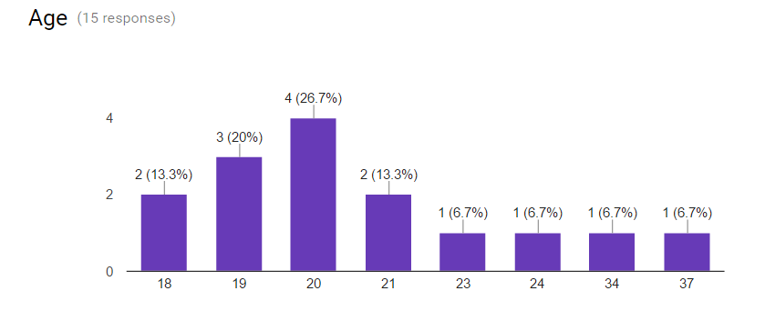

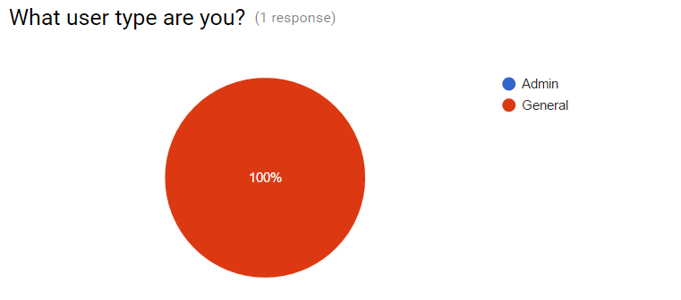

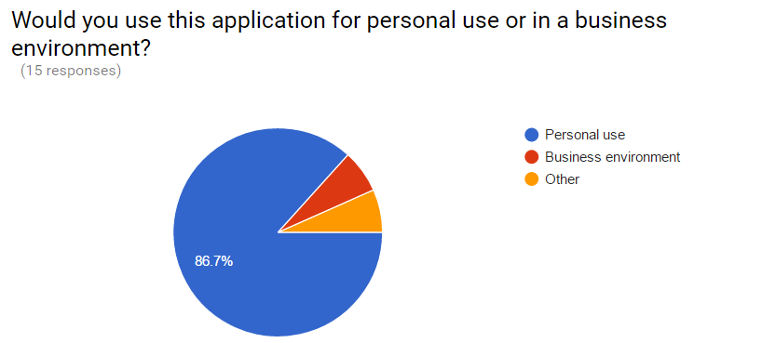

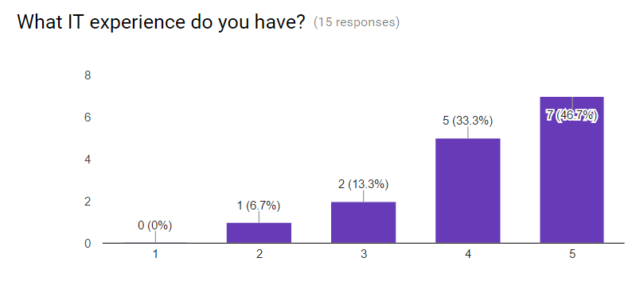

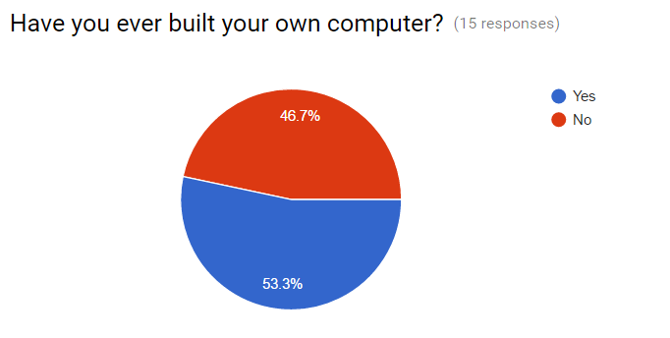

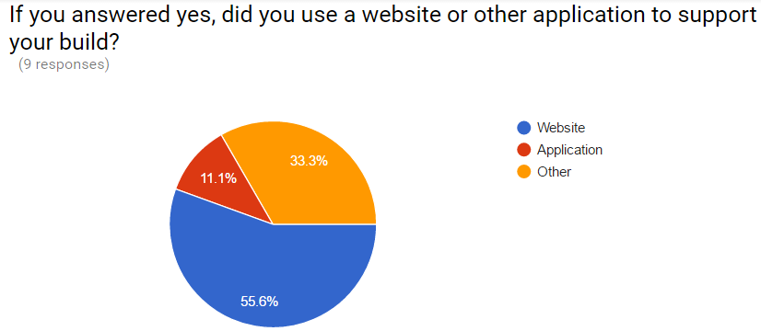

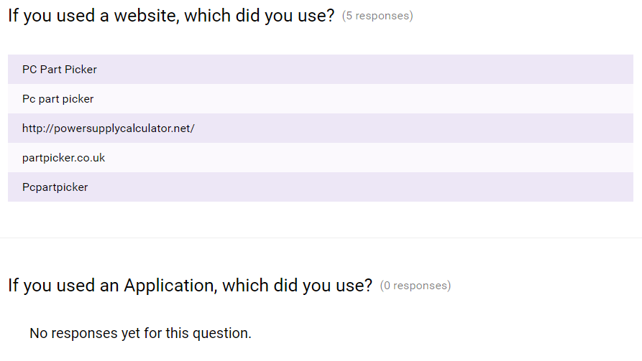

## What functionality would you expect?

|  |
| --- |
| Show compatibility between hardware |
| What is the application about |
| An ability to check different pc components |
| Good comparison of performance/price/build standards(ATX/ITX/etc) |
| Comparisons of compatibility between various components |
| Tell me how to build a PC |
| A basic guide on how to build a computer. Tell me what parts work with what other parts |
| Step-by-step how to build computer. |
| Show compatibility between hardware |
| Show compatibility |
| Check PC |
| Cost of the components |
| Educational factor, teach users about each part. When a user is missing a part the application will inform them that they are missing a part, and tell them to choose one. |
| Check PC |
| Cost of the components |
| Educational factor, teach users about each part. When a user is missing a part the application will inform them that they are missing a part, and tell them to choose one. |
| What is the application about |
| An ability to check different pc components for incompatibility and/or common building glitches |
| Comparison of performances |

## What accessibility would you expect?

|  |
| --- |
| None |
| N/a |
| Audio description, pictures |
| Audio descriptions would be great |
| Audio descriptions |
| Pictures of components to go with the descriptions |
| Language |
| None |
| None |
| Large text? |
| None |
| None |
| Ability to make text larger |
| Text to speech. |
| None |
| Ability to make text larger |
| Text to speech. |
| N/a |
| Clear layout of different components and how they stack up next to each other |
| Audio description, pictures |
| Audio descriptions would be great so when I’m building it can tell me what parts I need |
| Audio descriptions |

## User Interface

|  |
| --- |
| Easy to use, maybe with icons of the parts |
| Nice layout |
| Possibility to save/send/share your favourite set up |
| To be done in some sort of artistic way |
| Unsure |
| Easy to use, saveable set ups, drop down menus |
| Easy to use |
| Clear navigation |
| Icons |
| Clear navigation, ability to view more info on a piece of hardware |
| Easy to use |
| Easy to use |
| Drop down menu for each type of component, images of each component, reviews from other users |
| Icons, Clear text ,Easy to follow through |
| Easy to use |
| Drop down menu for each type of component, images of each component, reviews from other users |
| Icons, Clear text ,Easy to follow through |
| Nice layout |
| Menus, cross-checking |
| Possibility to save/send/share your favourite set up |
| To be done in some sort of artistic way |
| Unsure |

